RESOLUTION NO. 2023-__
A RESOLUTION OF THE CITY COUNCIL OF THE CITY OF MORENO VALLEY, CALIFORNIA, DECLARING PURSUANT TO CALIFORNIA GOVERNMENT CODE § 54221 THAT THE REAL PROPERTY IDENTIFIED AS 24124 AND 24108 FIR AVENUE (APNS 481-130-022 AND 481-130-023) IS SURPLUS LAND AND NOT NECESSARY FOR THE CITY’S USE AT THIS TIME, FINDING THAT SUCH DECLARATION IS EXEMPT FROM ENVIRONMENTAL REVIEW UNDER THE CALIFORNIA ENVIRONMENTAL QUALITY ACT, AND APPROVING CERTAIN RELATED ACTIONS
WHEREAS, this Resolution concerns that certain real property identified as 24124 and 24108 Fir Avenue (APNs 481-130-022 and 481-130-023) consisting of approximately 0.91 acres (approximately 39,600 square feet) located on the north side of Fir Avenue, east of Heacock Street, as more particularly described in Exhibit “A” and depicted in Exhibit “B” to this Resolution (the “Property”); and
WHEREAS, pursuant to the California Surplus Land Act, Government Code (the “GC”) §§ 54220-54234 (the “Act”), as amended by AB 1486 (Chapter 664, Statutes of 2019; “AB 1486”) and Guidelines promulgated thereunder by the California Department of Housing and Community Development (the “HCD”) dated as of April 2021 (the “Guidelines”), in order for the Property to be disposed of, such land must first be made available under a process set forth in the Act and expounded upon by the Guidelines; that process requires that a notice be given calling for written notices of interest after the affected public entity has designated such land as surplus by the taking of a formal action at a public meeting of such public agency; and
WHEREAS, pursuant to the Act, land is necessary for the City’s use if the land is being used, or is planned to be used pursuant to a written plan adopted by the City, for City work or operations; and
WHEREAS, the Act, as expounded upon by the Guidelines, provides that such land shall be declared either surplus land or exempt surplus land before the City may take action to dispose of it consistent with the City’s policies or procedures; and
WHEREAS, GC § 54222, requires the City, if it declares land to be surplus and not necessary for the City’s use, to provide written notice thereof to certain local public agencies and housing sponsors (the “Designated Parties”); the form of such notification is included as Exhibit “B” to this Resolution (the “Notification Process”); and
WHEREAS, the Notification Process concerns only the Designated Parties and provides the Designated Parties a 60-day opportunity to request to negotiate for the disposition of the Property consistent with parameters for such negotiations provided by the Act; and
WHEREAS, the Notification Process is not a request for proposals, does not bind the City to any disposition of the Property and does not supersede the applicable provisions of the Moreno Valley Municipal Code; and
WHEREAS, the Act does not impose any mandates or timeframes with respect to the disposition of real property; and
WHEREAS, if approved, this Resolution will confirm the City’s declaration that the Property is surplus and authorize the initiation of the Notification Process to the Designated Parties; and
WHEREAS, failure to follow the procedure described in the Act and expounded upon by the Guidelines for providing a notice of availability of surplus land and related actions, may subject the City to financial and other penalties and measures and may frustrate the ability of the City to further its achievement of its development goals pursuant to the City’s General Plan; and
WHEREAS, in addition to the foregoing, the HCD has certain oversight authority over negotiations with Designated Parties, if any, for the purpose of confirming that such negotiations were conducted within the parameters described in the Act; and
WHEREAS, approval of this Resolution will confirm the City Council’s declaration that the Property is surplus and not necessary for the City’s use at this time and authorize the initiation of the Notification Process as prescribed by the Act; and
WHEREAS, pursuant to § 15060 (c) (3) of the California Environmental Quality Act (the “CEQA”) Guidelines (i.e., California Code of Regulations, Title 14, Division 6, Chapter 3, §§ 15000-15387), approval of this Resolution is exempt from CEQA because the actions described herein will not result in a direct or indirect physical change in the environment and the actions described herein are not a “Project”, as defined within § 15378 of the CEQA Guidelines; and
WHEREAS, adoption of this Resolution does not have the potential for resulting in either a direct or indirect physical change in the environment. If and when the Property is sold or leased and that new owner or lessee proposes a use for the Property that requires a discretionary permit and CEQA review, that future use and project will be analyzed at the appropriate time in accordance with CEQA; and
WHEREAS, all of the prerequisites with respect to the approval of this Resolution have been met.
THEREFORE, BE IT RESOLVED, FOUND, DETERMINED AND ORDERED, by the City Council of the City of Moreno Valley, in regular session assembled on June 20, 2023, in the meeting room of the City Council located on the 1st floor of City Hall, 14177 Frederick Street, Moreno Valley, California, as follows:
1) That the City Council hereby finds and declares that the above recitals are true and correct and incorporated as though fully set forth herein.
2) The City Council hereby declares that the Property is surplus land and not necessary for the City’s use at this time and authorizes the initiation of the Notification Process as prescribed by the Act and as further expounded upon by the Guidelines.
3) The City Manager, or designee, is hereby authorized to do all things that are necessary or proper to effectuate the purposes of this Resolution, and any such actions previously taken are hereby ratified and confirmed. Such actions include negotiating in good faith in accordance with the requirements of the Act and the Guidelines with any of the Designated Parties that submit a written notice of interest as to the disposition of the Property in compliance with the Act.
4) This Resolution has been reviewed with respect to the applicability of the CEQA (Public Resources Code § 21000 et seq.). City staff has determined that the designation of the Property as surplus does not have the potential for creating a significant effect on the environment and is therefore exempt from further review under CEQA pursuant to State CEQA Guidelines § 15060(c)(3) because it is not a project as defined by the CEQA Guidelines § 15378.
5) The City Clerk is directed to file a Notice of Exemption pursuant to CEQA Guidelines § 15062.
6) This Resolution shall take effect upon the date of its adoption.
APPROVED AND ADOPTED this 20th day of June, 2023.

Ulises Cabrera, Mayor

ATTEST:

Jane Halstead, City Clerk

APPROVED AS TO FORM:

Steven B. Quintanilla, City Attorney

RESOLUTION JURAT

STATE OF CALIFORNIA )

COUNTY OF RIVERSIDE ) ss.

CITY OF MORENO VALLEY )

I, Jane Halstead, City Clerk of the City of Moreno Valley, California, do hereby certify that Resolution No. 2023 - was duly and regularly adopted by the City Council of the City of Moreno Valley at a regular meeting thereof held on the 20th day of June, 2023 by the following vote:

AYES:

NOES:

ABSENT:

ABSTAIN:

(Council Members, Mayor Pro Tem and Mayor)

Jane Halstead, City Clerk

(SEAL)

EXHIBIT “A”
PROPERTY DESCRIPTION

The real property in the City of Moreno Valley, County of Riverside, State of California, described as follows:

APN 481-130-022:

Lot 66 of the Edgemont Gardens Tract, as per Map recorded in Book 15, Page 90 of Maps, in the Office of the County Recorder of said County.

Excepting therefrom the Westerly rectangular 72.00 feet of said Lot.

APN 481-130-023:

The Westerly rectangular 72.00 feet of Lot 66 of the Edgemont Gardens Tract, as per Map recorded in Book 15, Page 90 of Maps, in the Office of the County Recorder of said County.

EXHIBIT “B”

CITY OF MORENO VALLEY

14177 Frederick Street / PO Box 88005, Moreno Valley, CA 92552
Telephone (951) 413-3000

NOTICE OF AVAILABILITY OF SURPLUS LAND
(Via Email)

Date: June 21, 2023

TO: Interested Local Agencies and Housing Sponsors

RE: Notice of Availability of Surplus Land in the City of Moreno Valley Pursuant to California Government Code § 54220, et seq.

Pursuant to the provisions of California Government Code § 54220, et seq., the City of Moreno Valley (“City”) hereby notifies interested local agencies and housing sponsors (“Designated Parties”) of the availability for lease or purchase of the following surplus City-owned land (“Property”):

Property Address: 24124 and 24108 Fir Avenue: Approximately 0.91 acres (39,600 SF) of vacant land located on the north side of Fir Avenue, east of Heacock Street
Assessor’s Parcel No.: APNs 481-130-022 and 481-130-023
Zoning: Specific Plan 204-Village Residential (VR)
General Plan Designation: Specific Plan 204-Village Residential (VR)
Current Use: 2 adjacent vacant lots

Copies of the aerial image and assessor map showing and depicting the Property are attached. Per Moreno Valley Municipal Code, Title 9, Planning and Zoning, Chapter 9.13, Specific Plans, the Property is located within Specific Plan area 204-The Village and is zoned Village Residential (VR); which in general provides for a range of residential densities and provides for certain other complementary land uses. For further information, see Chapter II of the Village Specific Plan at this link: http://www.moreno-valley.ca.us/cdd/documents/specific-plans.html. The Property is made available pursuant to this Notice in its “as-is and where-is” condition. The City will not provide a warranty with respect to the condition or suitability of the Property for any purpose.

A Designated Party desiring to purchase or lease the Property, which must include both parcels, for any of the purposes authorized by Government Code § 54222, must file a written notice of interest with the representative designated below by the Designated Parties within 60 days from the date of this Notice of Availability as confirmed by the date set forth below (since the 60th day falls on a weekend, the submission date has been extended to the following Monday). Designated Parties proposing to submit a notice of interest are advised to review the requirements set forth in the Surplus Land Act (Government Code §§ 54220-54234).

Please send written notices of interest via e-mail to:

Dena Heald, Deputy Finance Director, Financial & Management Services
14177 Frederick Street
PO Box 88005
Moreno Valley, California 92552
Denah@moval.org

With copies to:

Steven H. Dukett, Development Consultant to the City
2305 Chicago Avenue
Riverside, California 92507
Sdukett@TKEengineering.com

For further information, please contact Mr. Steven H. Dukett, Managing Director of Development Services, TKE Engineering, Inc. (development consultant to the City), at (909) 967-8205 or sdukett@TKEengineering.com.

Consistent with the foregoing, the final day to submit a written statement of interest to either lease or purchase the Property is Monday, August 21, 2023 by 5:00 PM.

Attachments (Aerial Image and Assessor Map)

Attachment No. 1

AERIAL IMAGE OF THE PROPERTY

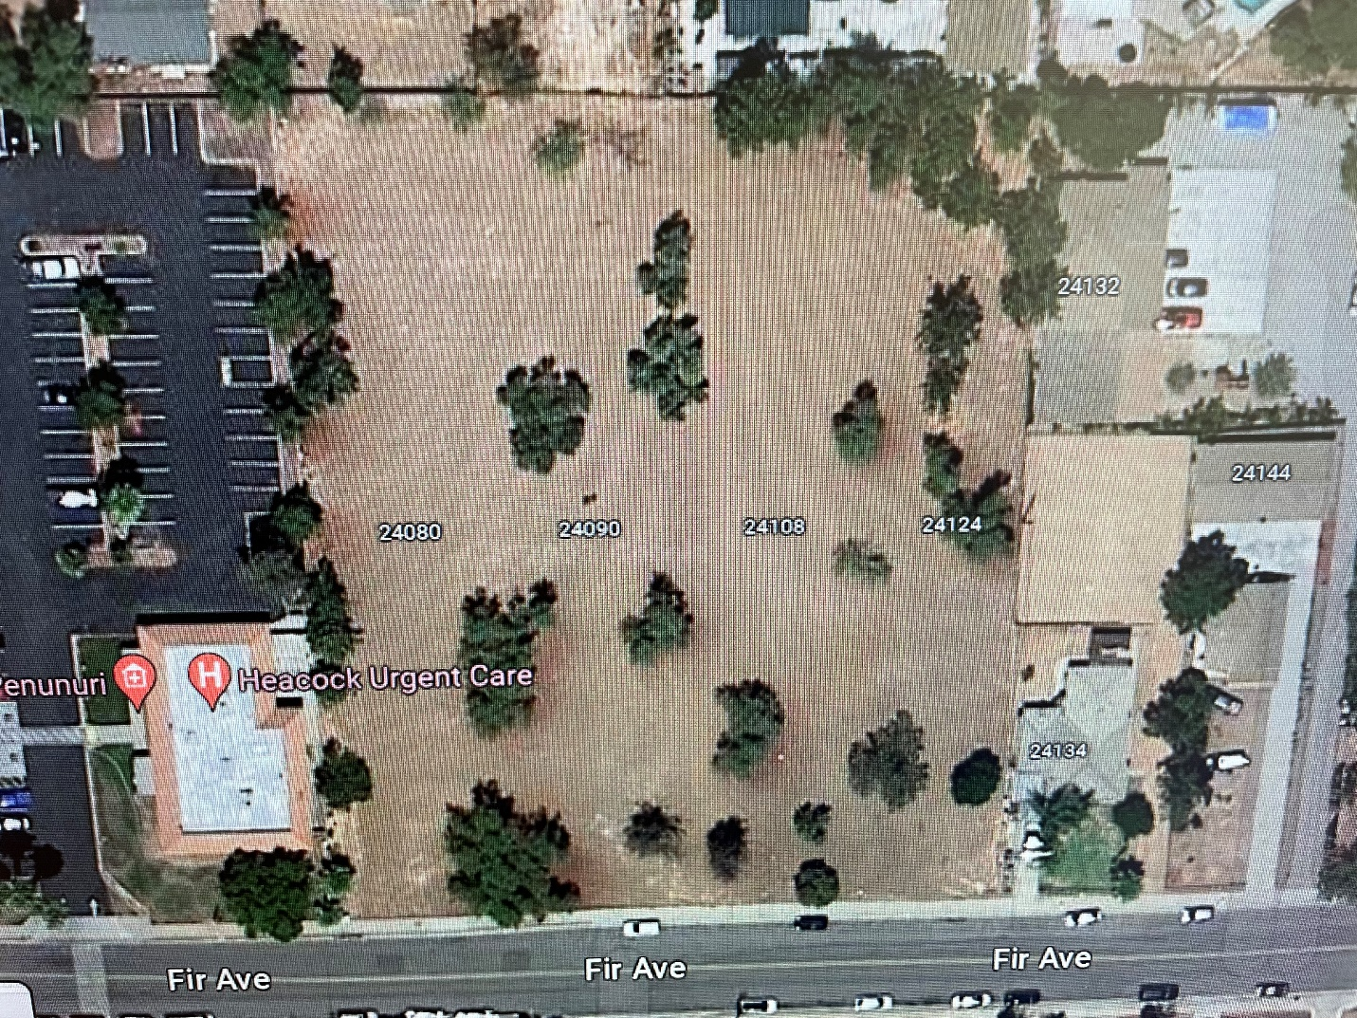

Attachment No. 2

ASSESSOR’S PARCEL MAP OF THE PROPERTY

